ATI
Advanced
Technology
Institute
Code of practice for working with Nanoparticles

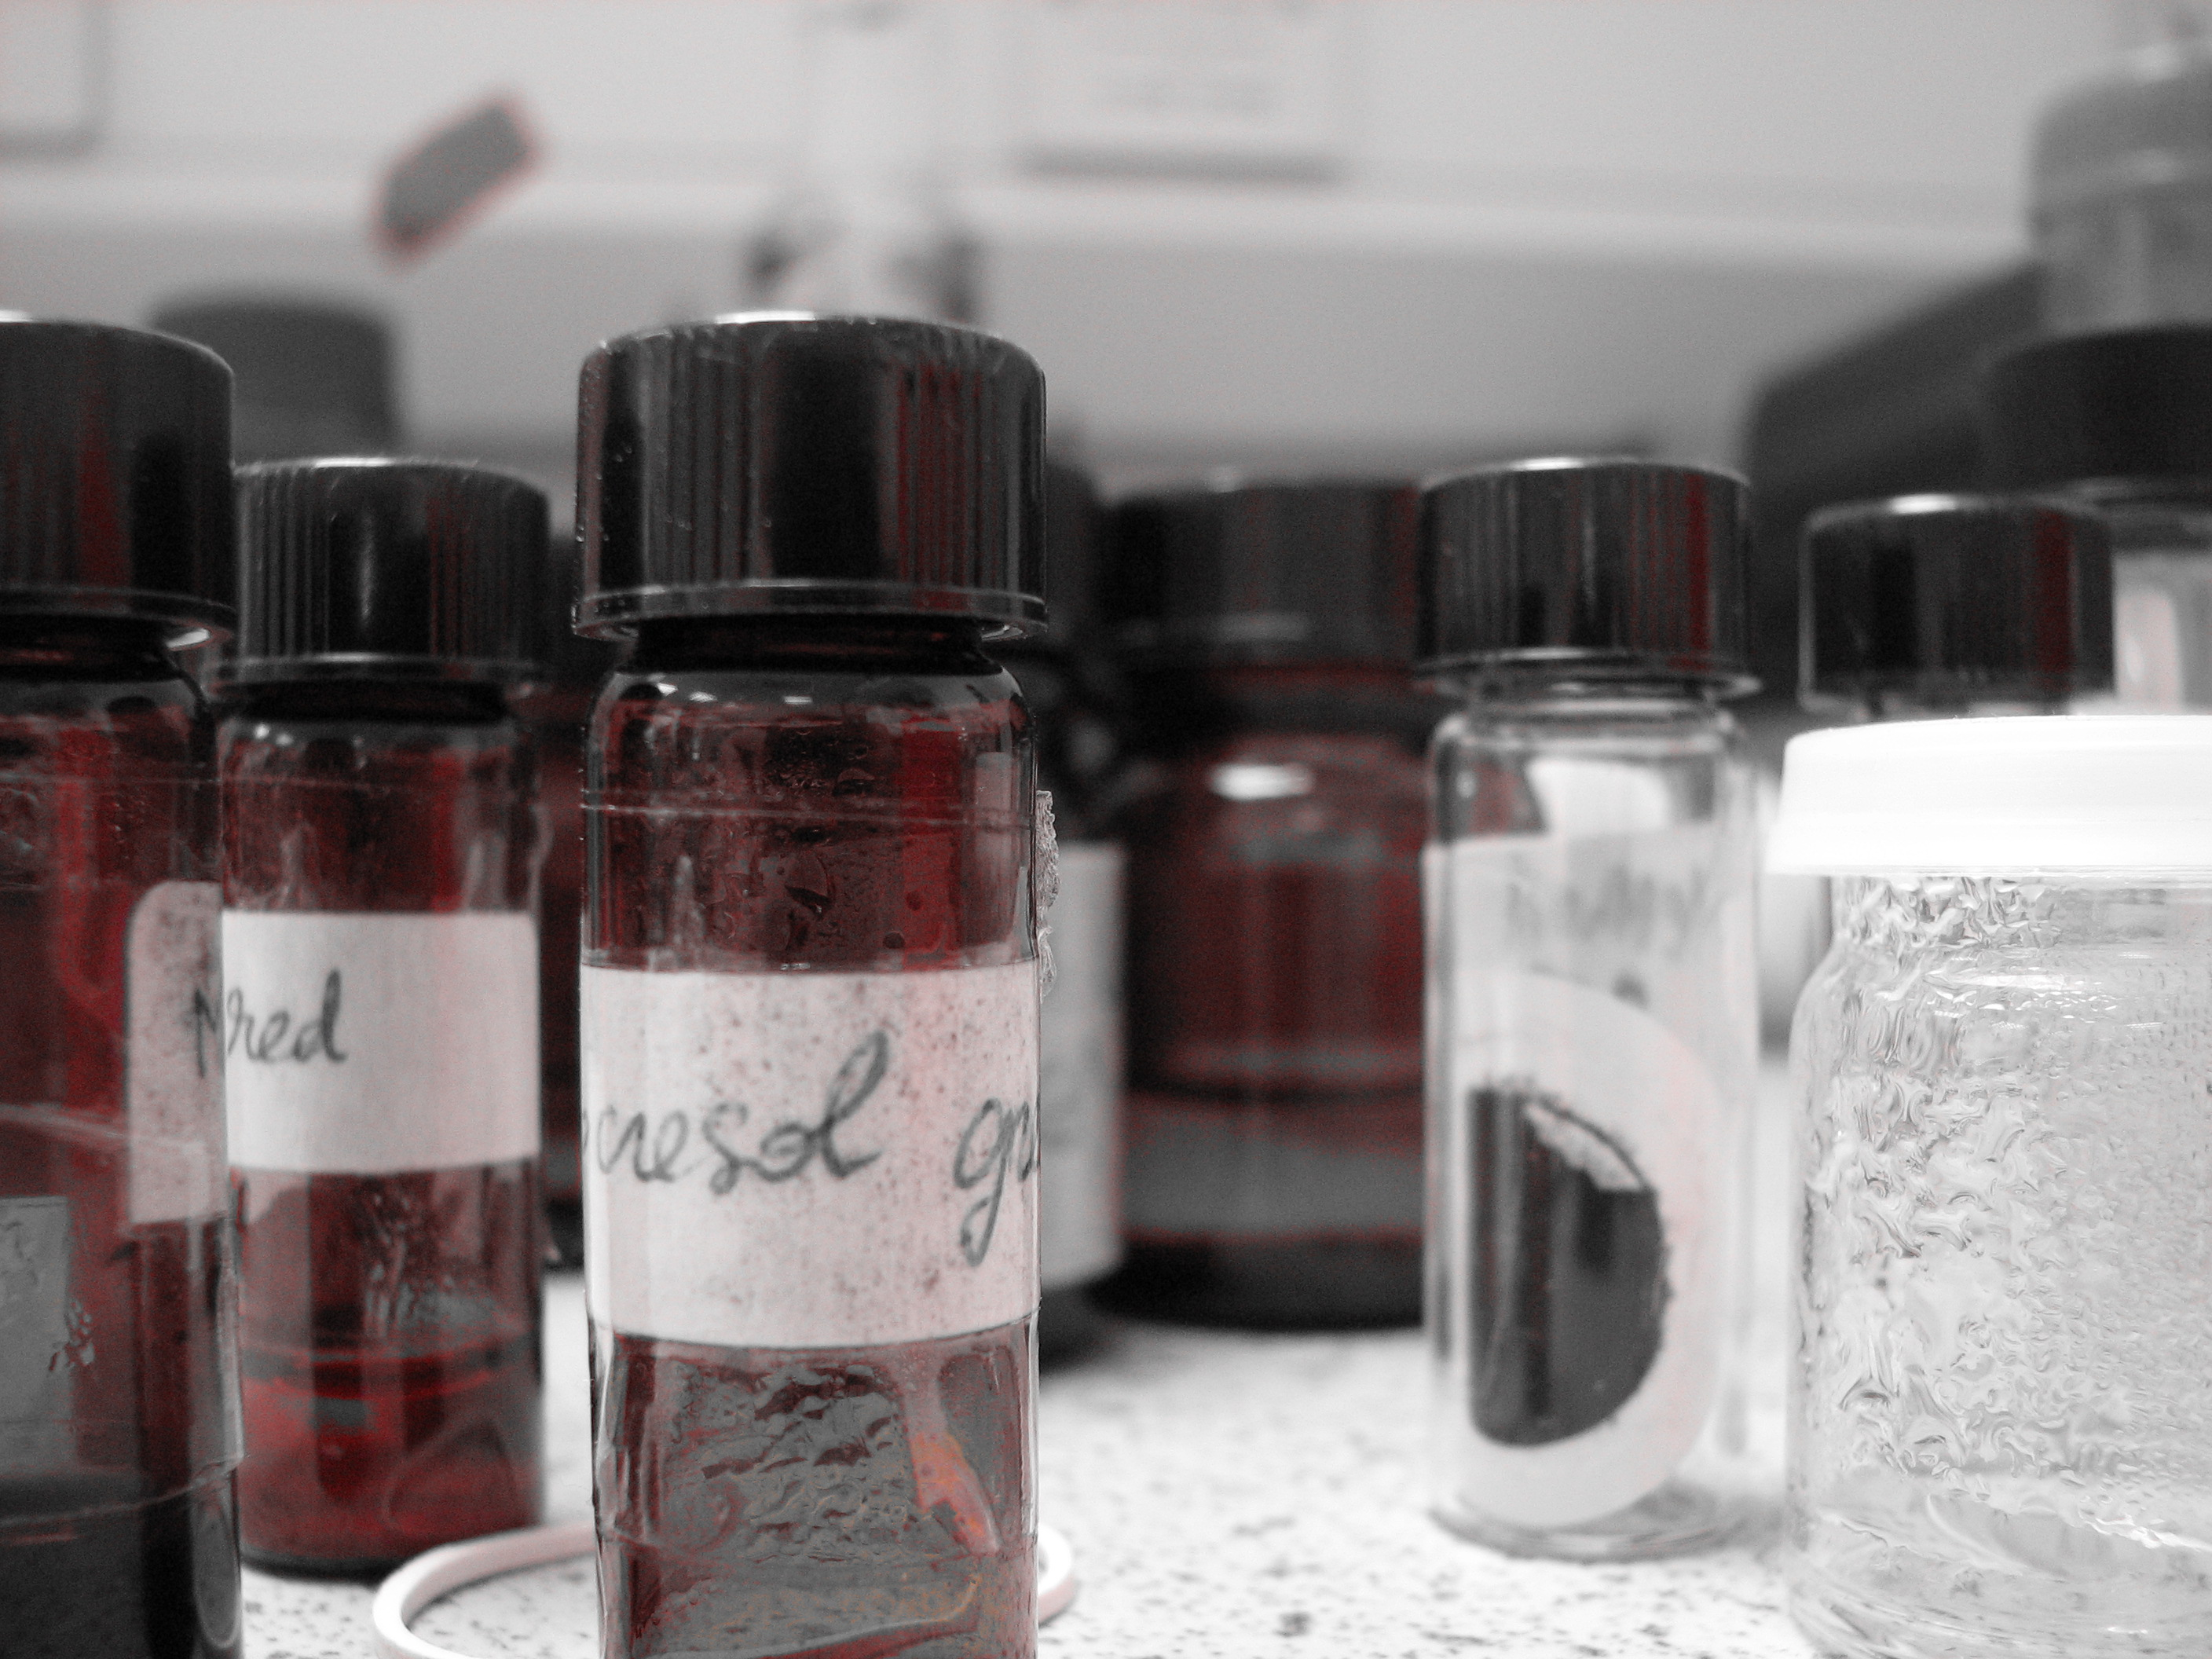

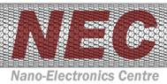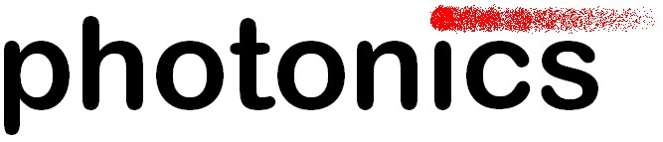

Code of practice - Nanoparticles

Contents

What are nanoparticles?
Carbon nanotubes
Fullerenes
Quantum dots
Ordering chemicals at the ATI

Standard operating procedure for using nanoparticles
- Chemical Vapour Deposition of Carbon Nanotubes
- Arc Discharge Deposition of Carbon Nanotubes
- Filling Single Wall Nanotubes with Metal Complexes
- Making PbS Quantum Dots
- Purification of Single Wall Carbon Nanotubes

What are Nanoparticles?
A nanometer (nm) is one thousand millionth of a metre. A human hair is about 80,000nm across and the diameter of a human blood cell is in the region of 7,000nm. Research into nanotechnologies considers sizes of around 100nm down to the size of atoms (approximately 0.2 nm). A nanoparticle is considered to be any three dimensional object that falls within this scale although for simplicity this also includes one dimensional entities (e.g very thin films) and two dimensional objects (e.g nanowires and nanotubes).

Far from being a recent invention, nanoparticles have existed since before the ascent of man and can be found in nature in the form of volcanic ash, ocean spray, smoke from forest fires, clay and clouds.

Research is so interested in developing nanotechnologies for two main reasons. Firstly, nanoparticles have a much larger surface area when compared to a similar material on a larger scale and this can make some materials more chemically reactive to the extent that some materials become reactive at the nanoscale that would be considered inert in larger form. Secondly, quantum effects can begin to dominate the behaviour of matter at the nanoscale affecting the optical, electrical and magnetic behaviour of materials.

Carbon Nanotubes
Japanese researcher Sumio Iijima working with NEC is credited with the discovery of carbon nanotubes in the soot of an arc discharge reactor in 1991. Carbon nanotubes exist in two forms – single wall tubes (SWNTs) and multiwall tubes (MWNTs). Soon after the discovery of carbon nanotubes, the possible applications became apparent and CNTs have the potential for future technological advances in electronics, materials science, medicine, etc. The main problem currently facing nanotubes research is high manufacturing cost and low yield of high purity CNTs although these problems will likely be overcome with development and refinement of synthesis techniques.

Carbon Nanotube Synthesis
Although there are several techniques for synthesising carbon nanotubes, two techniques are currently used at the ATI.

Arc Discharge: CNTs are formed by passing high current through two graphite electrodes positioned closely together in a closed vessel containing inert gas. An arc (or spark) is generated between the two electrodes causing the anode to be depleted and carbon nanotube material to form on the cathode.
Chemical vapour deposition (CVD): Synthesis is achieved by using a carbon bearing gas (e.g. acetylene) heated under low pressure. As the gas decomposes elemental carbon is formed and deposited on a substrate (usually metal coated silicon) forming carbon nanotube material.

Functionalising Nanotubes
Carbon Nanotubes can be functionalised with a wide variety of chemicals for a myriad of applications. When you are working with functionalised CNTs you should be aware of the specific risks of any chemicals involved as well as the CNTs. All processes must be covered by COSHH risk assessment.

Fullerenes
Fullerenes were discovered in 1985 by researchers at Rice University and are named after American architect and inventor Richard Buckminster Fuller. Fullerenes are often know as ‘buckyballs’ and were a precursor to the later discovery of carbon nanotubes. Buckyballs exist as an allotrope of carbon containing 60 atoms of carbon bonded to each other forming a spherical geodesic arrangement which looks similar to a football. The discovery of fullerenes was a major turning point for developmental chemistry and since discovery new forms have been developed with 70, 76 and 84 carbon atoms.

Quantum Dots
Quantum dots (QDs) are nanoparticles of semiconductor material and are unique as semiconductors because of their small size (typically 2nm to 10nm). In the 1970s quantum wells were developed and formed the basis of most optoelectronic devices. Further research led to the development of quantum wires and then quantum dots.

Band Gap Engineering
Optoelectronic devices such as LEDs use band gaps to excite electrons from their normal band to a higher energy band. When these excited electrons drop back down to their normal band they emit light as photons.

The colour, or frequency of light emitted depends on the size of the band gap and this can be controlled by changing the composition of the semiconductor alloy used or by creating layers of different semiconductor materials.

Quantum dots operate much more simply than other optoelectronic semiconductors as the size of the dot dictates band gap, which in turn determines the colour of light emitted. Quantum dots are still a recent development and have many applications yet to be discovered.

Ordering chemicals at the ATI
All orders for chemicals for use in the ATI should be made through John Underwood in room 01DJ01 (ext 6094). When chemicals arrive John will unpack them and pass them on to you and add any substances to the ATI inventory. Most nanoparticles will have to be ordered from specialist suppliers so may take some time to arrive.
Standard operating procedure (SOP) for activities involving nanoparticles

General Process Description
Nanoparticles exist in many forms (e.g carbon nanotubes, quantum dots), for ease of use this document considers all artificial particles of around 100 nm and smaller. Various laboratory processes and experiments are involved in research into nanoparticles so we shall only consider generic techniques for handling nanoparticles. Specific information for each individual process will have been produced by the researchers concerned.

Nanotubes and fullerenes exist in their native form as carbon but are frequently functionalised using other chemicals (e.g. for filling carbon nanotubes). Like many novel substances, nanoparticles and their effect on human health and the environment are not fully understood and as such they must be treated with care until fuller information becomes available.

Potential for workplace exposure
Insufficient data exists on airborne exposure to nanoparticles that are purposely produced and not incidental to an industrial process. The magnitude of exposure to nanoparticles when working with material on the nanoscale depends on the likelihood of particles being released during handling. In general, it is likely that processes generating nanoparticles in the gas phase, or using or producing nanoparticles as powders or liquids pose the greatest risk for release into the wider environment.
Exposure to engineered nanoparticles is likely to cause adverse health effects similar to well characterised ultrafine particles that have similar characteristics. At the nanoscale, surface area increases greatly and reactivity of substances increases. Whilst researchers working directly with nanoparticles are at risk, other groups of people may also risk exposure to nanoparticles, for example through servicing of air handling systems and during disposal of waste material.

Devices comprised of nanostructures, such as integrated circuits and composite materials, pose a minimal risk of exposure to nanoparticles during handling. However, if such materials are subject to machine working (e.g., cutting or grinding), or go through degradation processes that lead to the release of nanoparticles, then exposure may occur by the inhalation, ingestion, and/or dermal penetration of these particles.

Since data is generally lacking with regard to the generation of nanoparticles during the production and use of engineered nanomaterials, further research is required to determine exposures under various conditions.

Factors affecting exposure to nanoparticles
Exposure to engineered nanoparticles is dependent on many factors. Containment and engineering controls, the amount of material in use and duration/frequency of contact are the easiest factors to assess. Powders that can easily be dispersed, liquids which easily form droplets or aerosols and gases containing nanoparticles pose a risk in use.

In the case of airborne material, particle or droplet size will determine whether the material can enter the respiratory tract. Particles smaller that 10um in diameter have some probability of reaching the alveolar region deep in the lungs where gas exchange takes place. As particle size decreases to 4um or less this probability rises to 50%. Particles smaller than 30nm are likely to be deposited in the upper respiratory tract as well as in the alveolar region.

At present there is insufficient information to predict all of the situations and workplace scenarios that are likely to lead to exposure to nanoparticles. Some workplace factors that can increase the potential for exposure include:

- Working with nanoparticles in liquid media without adequate personal protection will increase the risk of skin exposure.

- Working with nanomaterials in liquid media during pouring operations will lead to an increased likelihood of inhalable and respirable droplets being formed.

- Working with nanoparticles in liquid or solid form during mixing operations such as crushing or sonication will increases the chances of exposure

- Generating nanoparticles in the gas phase in open systems will increase the chances of aerosol release to the workplace.

- Handling nanoparticles powders will lead to the possibility of skin and inhalation exposure.

- Maintenance on equipment and processes used to produce or fabricate nanomaterials will pose a potential exposure risk to workers performing these tasks.

- Cleaning of dust collection systems used to capture nanoparticles will pose a potential for both skin and inhalation exposure.

- Disposal of waste material containing nanoparticles will pose a risk of exposure during collection, transport and incineration.

Procedures to limit exposure
Given the limited information available regarding engineered nanoparticles and their effects during workplace exposure, working procedures and engineering controls should be tailored for each individual process where exposure may occur. Whilst this may be practical in an ideal world, in reality financial and space constrains make the use of specific apparatus for each individual process impractical.

For most processes and tasks, the control of airborne exposure to nanoparticles can most likely be achieved by using existing engineering controls, safe working practices and as a last line of defence personal protective equipment.

Engineering controls
Local exhaust ventilation (LEV) systems should be sufficient for protecting individuals from exposure whilst working with nanoparticles. High efficiency particulate air (HEPA) filters must be employed in any LEV dealing with nanoparticles.
HEPA filters should be contained in a suitably designed filter housing – if the filter housing is improperly sealed nanoparticles have the potential to bypass the filter.

Work Practices
The incorporation of good working practices can help to minimise personal exposure to nanoparticles. The following practices should be adopted in all areas where nanoparticles are handled:

Work areas should be cleaned at the end of each day using a HEPA filtered vacuum cleaner. Dry sweeping or pressurised gas hoses should not be used for cleaning as these will distribute nanoparticles in the air. Cleanup should be performed in such as way as to prevent personal contact with any waste material.

The storage and consumption of food and beverages is not permitted in all areas where nanomaterials are handled. Hand washing facilities are provided in all areas where nanoparticles are present and researchers & staff are encouraged to use these facilities before leaving the area. All waste that contains (or may contain) nanoparticles is to be disposed of in a clearly labelled container and is to be treated as hazardous waste.

Personal Protective Equipment (PPE)
Currently there are no guidelines on the suitability of protective clothing in preventing dermal exposure to nanoparticles. Testing has been carried out on a variety of materials with varying rates of efficiency.

It is recommended that disposable powder free gloves, lab coat and goggles are worn at all times when handling nanoparticles in a LEV scenario.
For situations where LEV is not practical the addition of a dust mask is suggested with the area cleaned both before and after the process using a HEPA class vacuum cleaner.

Cleanup and disposal of nanomaterials
No specific guidance is currently available regarding the cleaning of spills of nanomaterials or for making safe nanomaterial contaminated areas. Until such guidance becomes available it is suggested that any spills or contamination are dealt with according to current good practice.

Standard approaches to cleaning up powder and liquid spills include the use of HEPA-filtered vacuum cleaners, wetting powders down, using dampened cloths to wipe up powders and applying absorbent materials. Any cleaning materials or cloths used should be disposed of as waste to avoid re-use and then drying out and redistributing nanoparticles into the air.

Whilst vacuum cleaners may be an effective tool for dealing with nanomaterial spills and waste, electrostatic charges built up on vacuum cleaner hoses may result in dispersing rather than containing nanoparticles unless the design is such that any charges are neutralised.

Currently waste nanoparticles are transferred into a bottle containing 30% propan-2-ol and Decon 90 (a surfactant) and then handled as non-halogenated solvent waste, although this may be subject to change when safety guidance is published. However waste is dealt with, it should be clearly labelled such that waste can be properly recorded and handled in the most suitable manner for later disposal.

Recommended Handling Techniques
Firstly and foremost all efforts MUST be made to prevent nanoparticles from entering the wider environment and where possible should be handled using local exhaust ventilation.

Extreme care should be taken when collecting engineered nanoparticles from experimental apparatus to avoid raising dust. Current dust mask technology has limited effectiveness protecting against nanoparticles.

Any functionalised nanoparticles should be treated as considerably more of a risk to health than the material used in processing (filled nanotubes for example). Even gold nanoparticles should be considered a risk to health.

‘Cradle to grave’ analysis
Obtain MSDS for all chemicals, gases and raw nanoparticles used
Write COSHH risk assessment & SOP specific to process
Have paperwork checked and signed by supervisor / DSA as appropriate
Refer to John Underwood for order of chemicals providing full info including cost code
Transport chemicals and raw materials to work area
Consider risk assessment and adjust if necessary once process is ready to begin
Carry out process in accordance with agreed SOP adhering to all recommended actions
Collect final samples and contain waste material for disposal

Future Research
The following topics are just some of the areas being researched at various institutions in order to improve the understanding of nanoparticles and to ensure as safe a working area as possible.

- Investigating the properties and physical characteristics (shape, size etc) of nanoparticles and how this relates to toxicity.
- Evaluating short and long term exposure and effect on specific organs and determining biological mechanisms of toxic effects.
- Examining whether a measure other than mass is more suited for determining toxicity.
- Evaluating potential hazards and predicting potential occupational risk of exposure to nanomaterials.
- Evaluating the efficiency of engineering controls in reducing exposure to nanoparticles.
- Assessing possible exposure when nanomaterials are inhaled or settle on the skin.
- Determining what happens to nanoparticles once they enter the body.
- Identifying uses of nanotechnology for application in occupational health and safety

Nanotechnology processes at the ATI
There are a number of processes currently taking place at the Advanced Technology Institute that involve the use or engineering of nanoparticles. These processes are detailed below indicating how nanoparticles are dealt with and later disposed of. Each process considers handling the raw materials used, products and waste created and how this is dealt with as safely as possible.

Chemical Vapour Deposition (CVD) Deposition of CNTs
Chemical Vapour Deposition is a general technique of deposition of materials using chemical reaction of vapour on the surfaces of the sample. In carbon nanotubes or nanofibres deposition, this is usually aided with a transition metal catalyst e.g. Nickel, Iron, Cobalt.

Procedure involves putting a catalyst coated substrate (usually silicon wafer) into the chamber. The deposition can be either plasma or non-plasma based (i.e. thermal CVD). The growth typically constitutes the steps of heating up the substrate under an inert gas atmosphere, introduction of a hydrocarbon gas e.g. acetylene, methane, etc for desired amount of time, and cooling of the sample under an inert gas. If plasma enhanced CVD is used, it is ignited in the step where the hydrocarbon is introduced.

The process can be comparatively safer than bulk nanomaterials handling because:

- The nanotubes are attached to the substrate,
- The chamber is operated in vacuum and purged with inert gases and
- Cooling stage is typically over an hour under inert gas environment.

However, the following guidelines are recommended:

- Ensure chamber vacuum is better than pressures of 5E-2 torr before process.
- Ensure chamber temperature is less than 80°C before venting.
- Ensure chamber is purge with an inert gas for at least 2 mins and pumped to ultimate pressure before venting the system.
- After sample is removed from chamber, it is to be stored in an enclosed container. The nanotubes are attached to the sample substrate thereby providing safe handling of the sample (provided purge process is carried out).
- Chamber is then cleaned using oxygen plasma. All carbon nanomaterials would be etched away using the reactive oxygen species generated by the plasma.

Further points to note is that as the CVD systems are constantly under vacuum, being serviced by pumps. The gas flows would always be towards the pump, thereby carrying floating nanomaterials in that direction. As both inlet and outlet of the pumping system are filtered, most nanomaterials would be trapped in the filters before entering the exhaust.

CVD Content by GY Chen

Arc Discharge Deposition of CNTs
Carbon nanotubes are formed by passing high current through two graphite electrodes positioned closely together in a closed vessel containing inert gas. An arc (or spark) is generated between the two electrodes causing the anode to be depleted and carbon nanotube material to form on the cathode.

Graphite rods are placed in the chamber using nitrile gloves. After which the chamber is sealed and evacuated. After evacuation the chamber is allowed to fill with helium gas and remains sealed. Once the chamber is filled with helium vacuum pumps are no longer required and are turned off and disconnected from the chamber. This minimises any chance of nanoparticles entering the vacuum system when opening the chamber once processing is completed.

Once the chamber is helium filled and the sealed to prevent any entry of air into the system the arc discharge process takes place according to an established standard operating procedure approved by the University safety office.

After the arc-discharge process has completed and the chamber has sufficiently cooled, the end flange is removed. The user is required to wear nitrile gloves, goggles and lab coat. The graphite anode and cathode are carefully removed by hand taking care not to raise any dust and placed in a suitable container. The chamber is cleaned by carefully dislodging the soot deposit on the inner chamber wall using a brush, after which the soot is removed from both the brush and the chamber using a HEPA filtration vacuum cleaner. The chamber is finally cleaned using a paper towel and a small amount of acetone.

The extraction of CNTs from the cathode deposit takes place in a fume cupboard and requires the user to wear appropriate protective gear as in the previous paragraph, and following this procedure:

- Cathode deposit is detached from graphite rod.
- Cylindrical deposit cracked into two halves using a scalpel.
- Soft black core is scraped out of the amorphous grey shell and collected on paper.
- Black powder transferred to mortar and pestle and ground.
- Black powder is then transferred to a sample bottle and sealed for future experiments.

Disposal of waste products
The cast-off graphite rods are collected in a labelled container and disposed of as hazardous waste material in accordance with University safety policies.
The amorphous carbon shells are disposed of in the same way.

Arc Discharge Content by Paul Watts

Filling SWNTs with metal and semiconducting complexes
Procedure involves heating mixtures of single wall carbon nanotubes with various metal complexes in a tube furnace. Exact methodology depends on the choice of filling material. Wherever possible the processes are conducted inside a fume hood to ensure ventilation of hazardous gases and nanoparticles. All chemicals are stored individually according to the recommended guidelines for each compound.

Chemicals utilised to date are: -
SWNTs; ~ 1.4 nm in diameter and up to several hundred microns in length. The nanotubes are generally bundled together producing nanoparticles larger than the individual nanotubes.

Silver Nitrate (AgNO₃) in solid form
Mercury Telluride (HgTe) in solid form

Germanium Telluride (GeTe) in solid form

Personal protection that is used includes gloves, safety glasses and lab coat. Currently, weighing of the samples is not possible within the fume hood. As such a face mask is used when handling HgTe, GeTe and SWNTs to protect against airborne dust.

Products containing HgTe

A black powder consisting of nanotubes and HgTe is kept for analysis or disposed of.
- Disposal involves dispersal of the product in a solvent such as acetone then deposited in the university solvent waste bottle.
- Pure mercury beads are absorbed using a mixture of anti-spillage crystals and zinc powder.

Products containing GeTe

Given the similarity of the filling procedure for both HgTe and GeTe, the same rules apply for disposal and protection measures as described above for HgTe.

Products containing AgNO₃

- Initially AgNO₃ is stirred with nanotubes in deionised water
- The resulting solution is filtered to remove excess AgNO3
- A black powder containing nanotubes and AgNO3 is heated in the tube furnace, under vacuum to remove desorbed gases and water vapour
- Post heating, the black powder, now containing nanotubes and Ag metal is either stored, away from heat and potential sparks, for further analysis or disposed of
- Disposal involves dispersal of the product in a solvent such as acetone then deposited in the university solvent waste bottle.

Filling CNT content by Dan Henwood /Cristina Giusca

Making PbS Quantum Dots
The process involves injecting a sulphur reagent in a flask containing a lead compound, and the product is oleic acid (or long chain amine) capped PbS nanoparticles. This part or the process is carried out is the fume cupboard, and proper protection gear is worn at all times.

These particles are then precipitated out of the solution by addition of solvent and centrifugation. In order to minimise exposure to particles, o-ring sealed Teflon centrifuge tubes are used when possible.
Finally, the particles are kept in their dry form or dissolved in chloroform and stored in vials.
All the waste is disposed of in the ATI non-chlorinated or chlorinated, depending on the case, solvent waste system.
The glassware is immersed for at least 24h in Decon 90 that cleans it and destroys the nanoparticles.

It is noteworthy that these particles are capped by long chains organic molecules, which reduce their reactivity and their volatility, as the dried particles form a sticky solid.

It is also noteworthy that, although dissemination should be avoided as much as possible, I cannot wash my hands after I work in the prep lab: as the tap-sink we are supposed to use to this aim is also used for chemistry purposes, it is certainly contaminated and touching it without gloves might contaminate your hands more than the washing will clean them.

Purification of SWNT
SWNT are weighted, put in a crucible, heated up in a tubular furnace, left to cool down and subsequently treated with HCl 1M and filtered, then dried.

In order to avoid dissemination, the container in which they are held is covered when possible. As the nanotubes are damp most of the time, they are in the form of big lumps and thus much less prone to dissemination.

QD / SWNT content by Thierry Lutz

